**SQL Hackathon 2.0 -Solutions**

**1. Triangles Data**

**The TRIANGLES table is described as follows:**

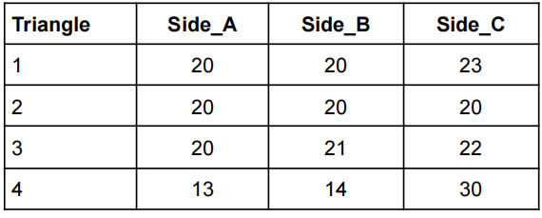

**Questions :**

**Q1. Write a query to create the TRIANGLES table.**

**Ans.1)**

**CODE:** CREATE TABLE TRIANGLES

( TRIANGLE integer,

SIDE_A integer,

SIDE_B integer,

SIDE_C integer,

PRIMARY KEY(TRIANGLE) );

INSERT INTO TRIANGLES VALUES ('1', '20', '20', '23'),('2', '20', '20', '20'), ('3', '20', '21', '22'), ('4', '13', '14', '30');

**Output:**

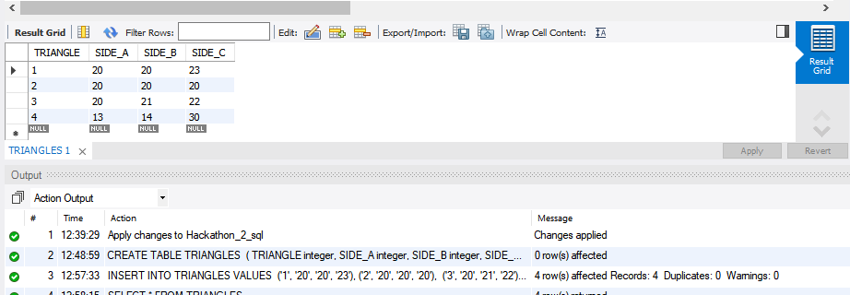

**Q2. Write queries to get output as per required :**

**i) Write a query to obtain the sum of side_A of all triangles.**

**Ans.2.i)**

**CODE:** SELECT sum(SIDE_A) FROM TRIANGLES;

**Output:**



**ii) Write a query to obtain an equilateral triangle from the table.**

**Ans.2.ii)**

**CODE:**

SELECT * FROM TRIANGLES

WHERE SIDE_A = SIDE_B AND SIDE_B = SIDE_C

**Output:**

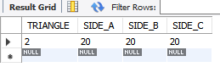

**iii) Write a query to obtain an isosceles triangle from the table**

**Ans.2.iii)**

**CODE:**

SELECT * FROM TRIANGLES

WHERE SIDE_A = SIDE_B OR SIDE_A = SIDE_C OR SIDE_B = SIDE_C ;

**Output:**

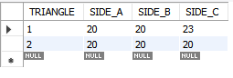

**iv) Find the no. of triangles in the table.**

**Ans.2.iv)**

**CODE:** select count(triangle) from triangles;

**Output:**



**v) Find the length of side_B of Triangle 3.**

**Ans.2.v)**

**CODE:** select triangle, side_b from triangles WHERE triangle=3;

**Output:**



**2. Employees Data**

**The Employees table is described as follows :**

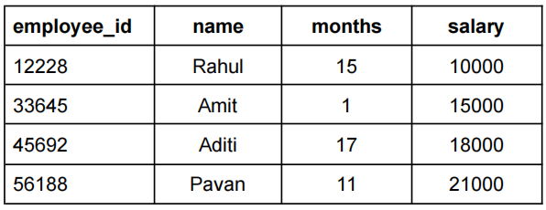

**Questions :**

1. **Write a query to create the Employees table:**

**Ans 1)**

**CODE:**

CREATE TABLE Employees

(employee_id INTEGER,

name VARCHAR(20),

months INTEGER,

salary FLOAT(10,3),

PRIMARY KEY(employee_id) );

INSERT INTO Employees VALUES

( '12228', 'Rahul', '15', '10000'),( '33645', 'Amit', '1', '15000'),( '45692', 'Aditi', '17', '18000'),( '56188', 'Pavan', '11', '21000');

**Output:**

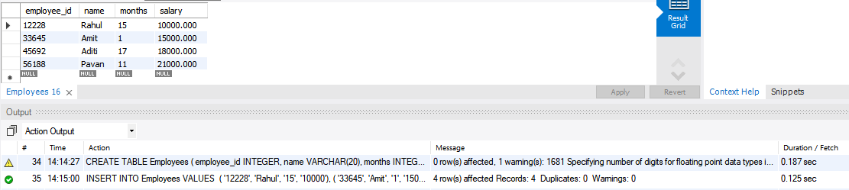

**2. Write queries to get output as per required :**

**i) Count the total no. of employees.**

**Ans.2.i)**

**CODE:** SELECT count(employee_id) FROM employees;

**Output:**



**ii) Find the salary of Rahul.**

**Ans.2.ii)**

**CODE:** SELECT employee_id, name, salary FROM employees WHERE NAME='RAHUL' ;

**Output:**

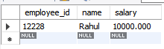

**iii) Set Amit’s months to 12.**

**Ans.2.iii)**

**CODE:** UPDATE employees SET months=12 WHERE employee_id='33645' ;

**Output:**

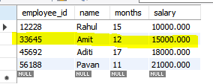



**iv) Find the sum of salaries of all employees.**

**Ans.2.iv)**

**CODE:** SELECT sum(salary) FROM employees;

**Output:**



**v) Find no. of employees whose name starts with ‘A’.**

**Ans.2.v)**

**CODE:**SELECT COUNT(name) FROM employees WHERE name like 'a%';

**Output:**



-------------------------------------------------------------------**COMPLETE**------------------------------------------------------------------------------